1. Click on Project

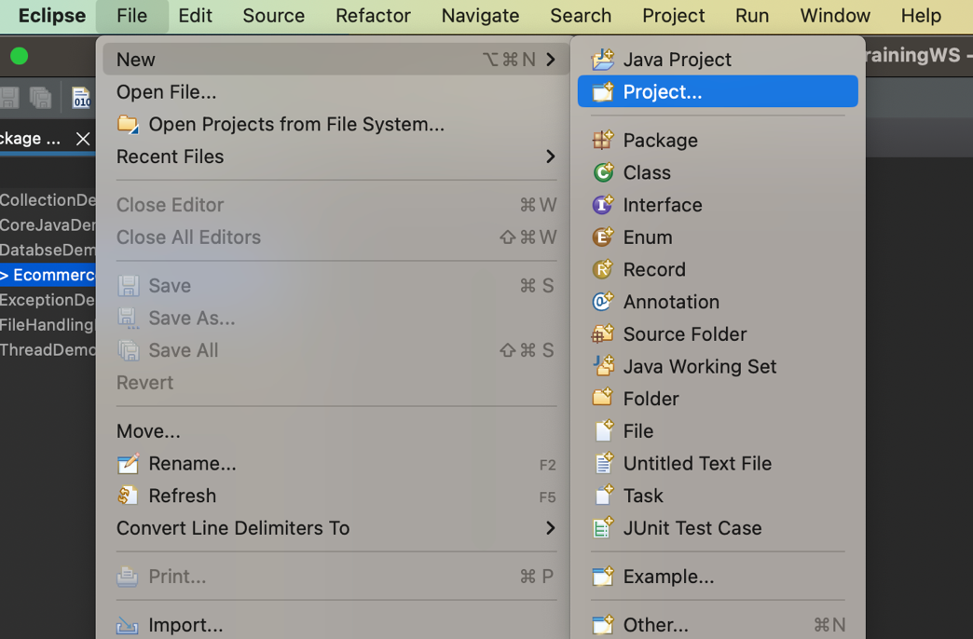

1. Choose Dynamic Web Project  
     
   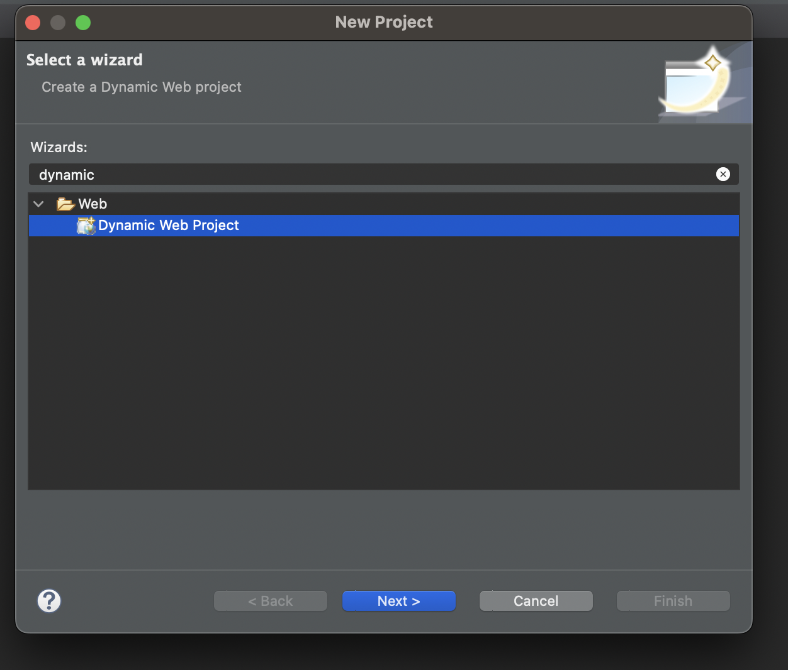
2. Enter Project name. Click New Runtime  
     
   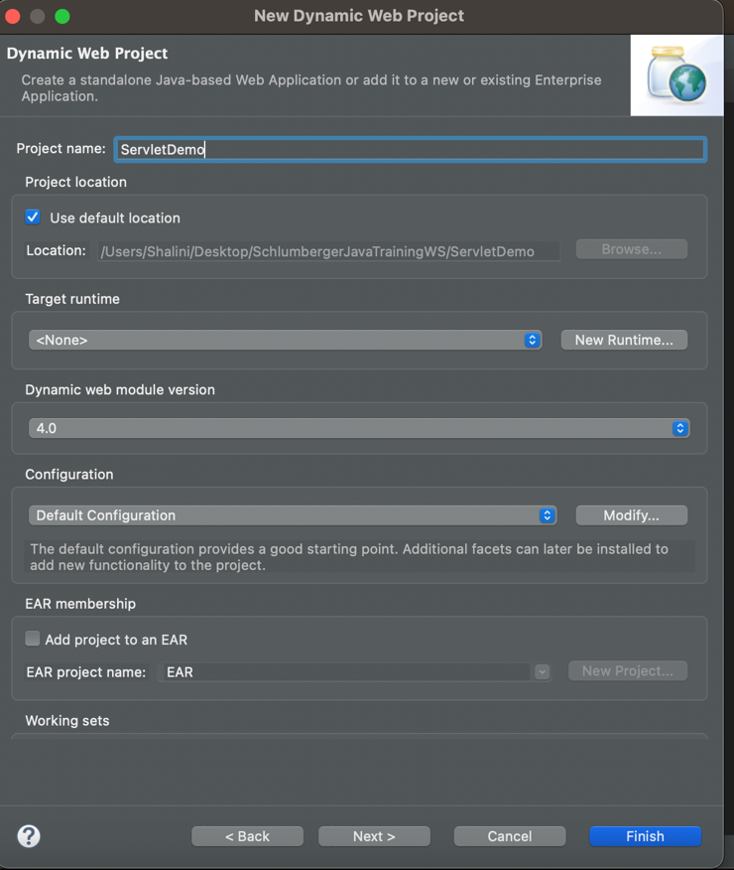
3. Select appropriate tomcat version downloaded

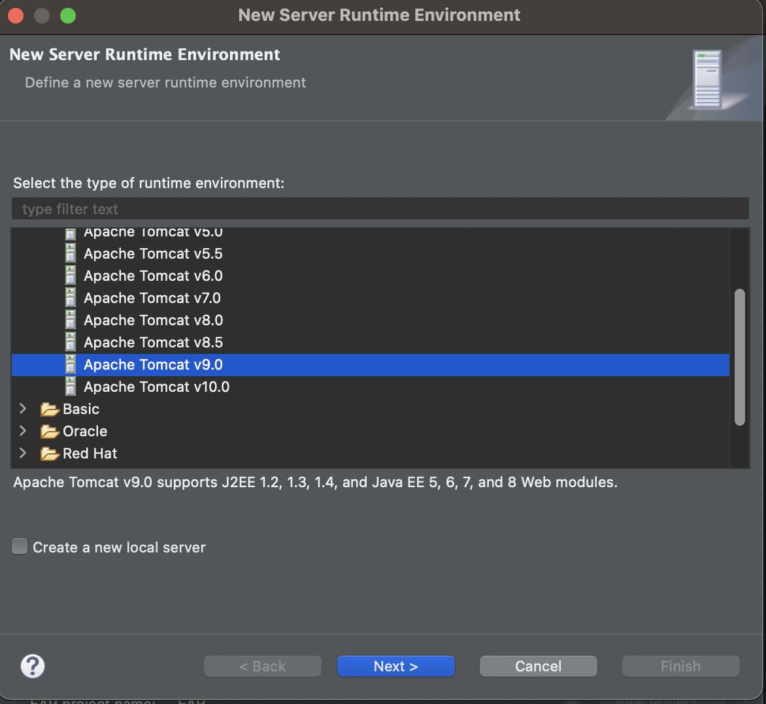

1. Click Browse

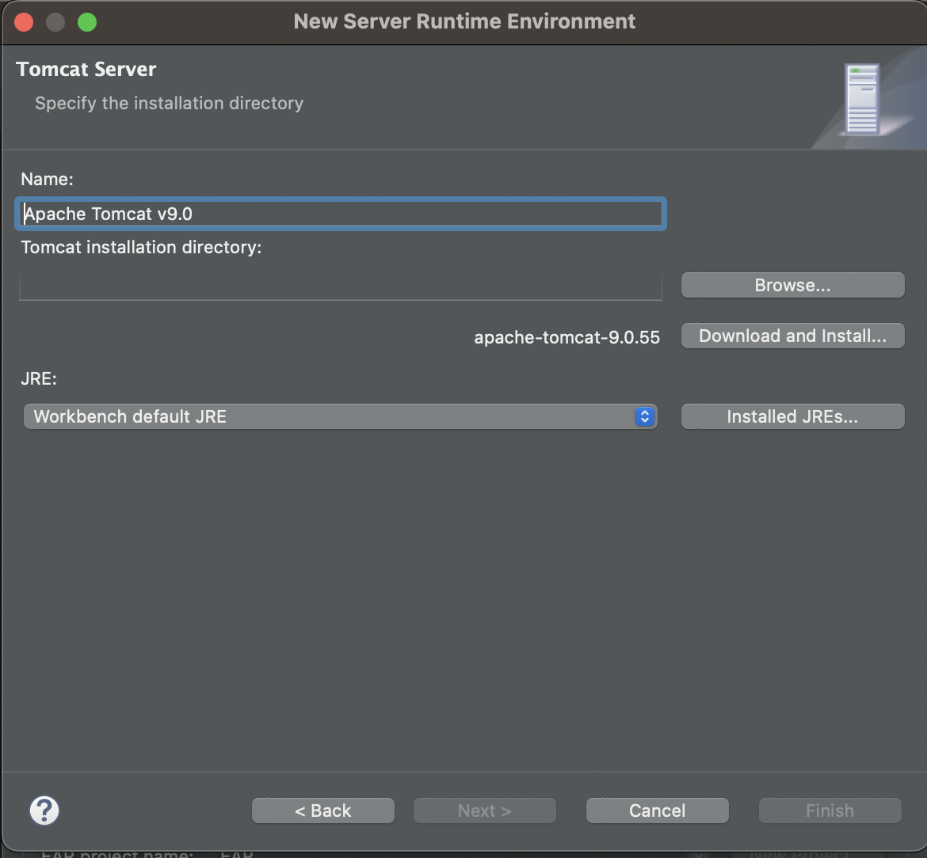

1. Choose the tomcat folder, click Open  
     
   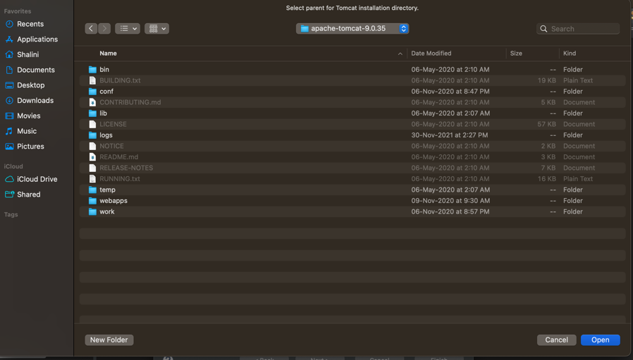
2. It should appear in the screen as below , click Finish

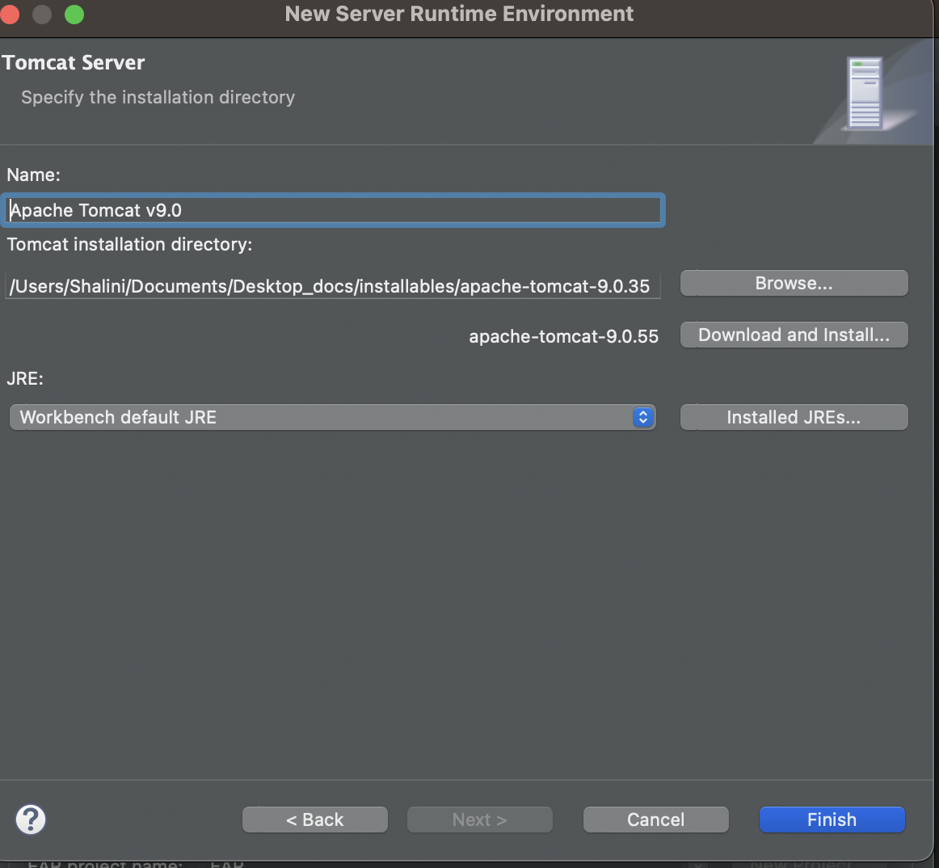

1. Target Runtime is updated. Click Finish.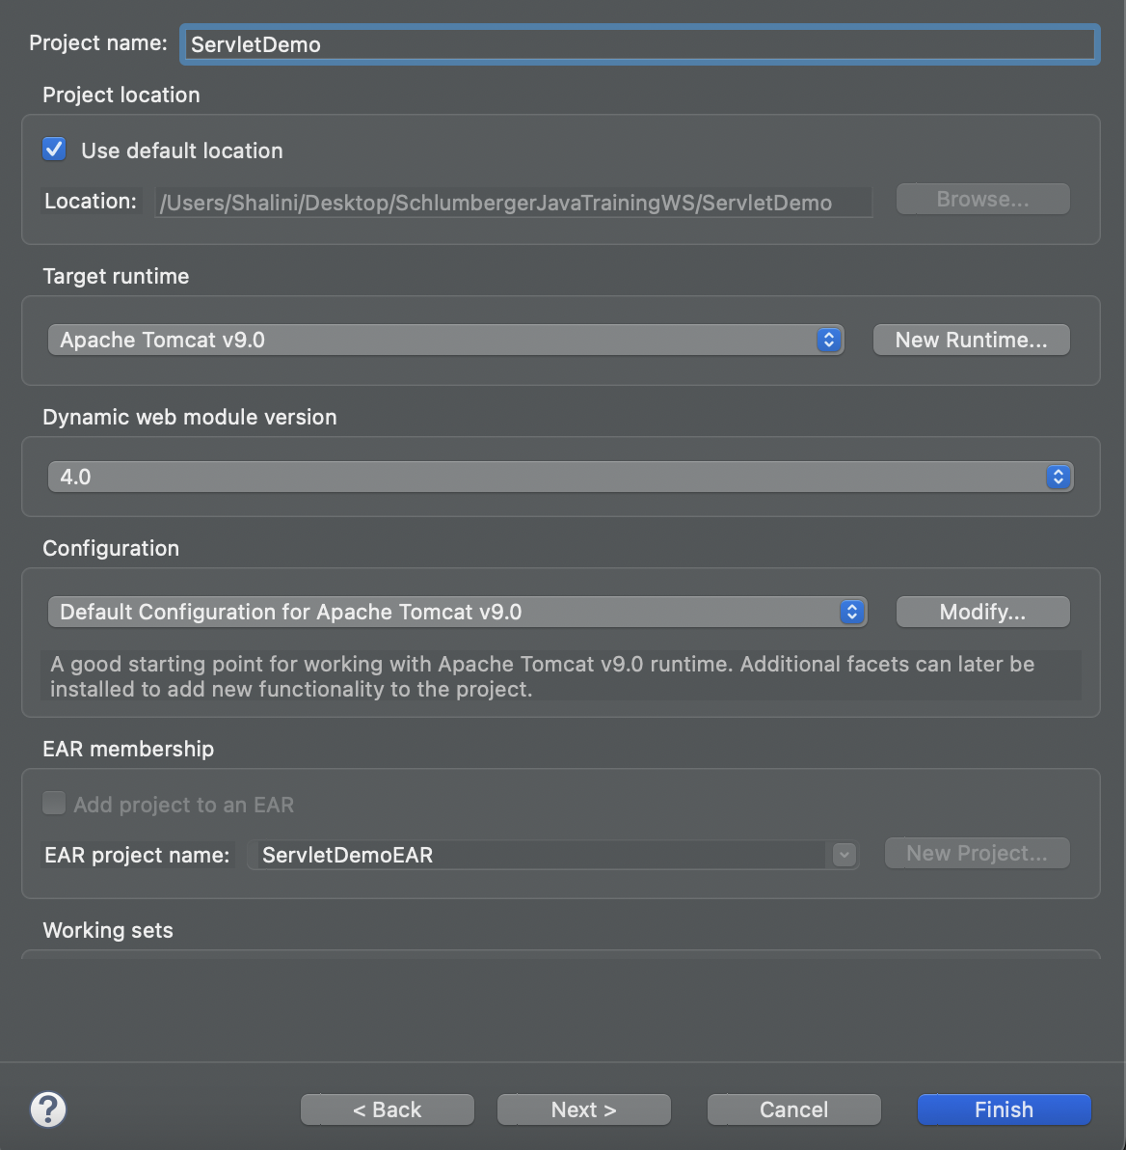
2. Choose Open Perspective if it asks:

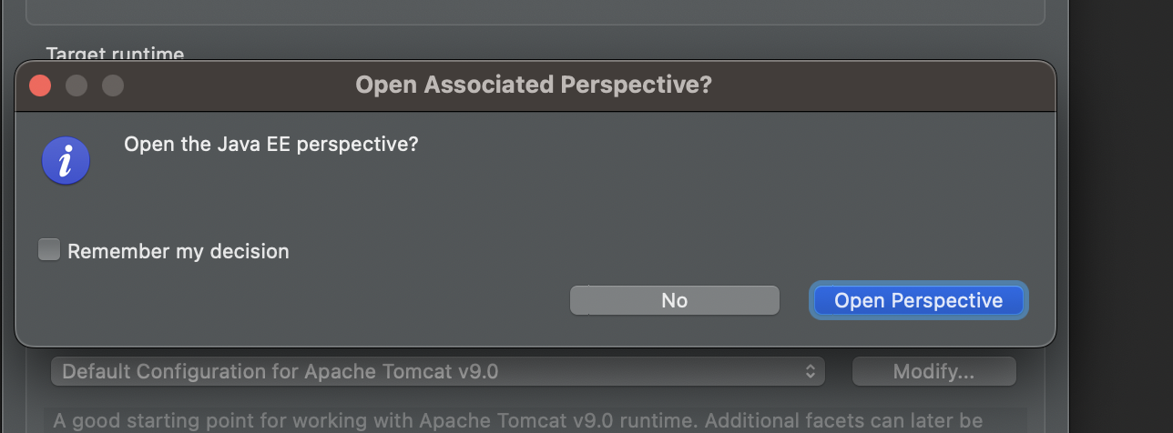

1. Once the project is created in workspace, Expand the folder and rt click on webapp => New => JSP File  
   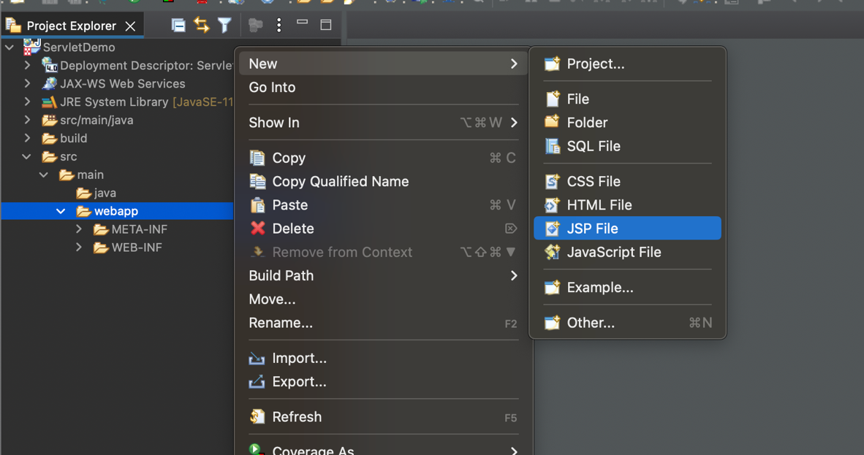
2. Give name index.jsp  
     
   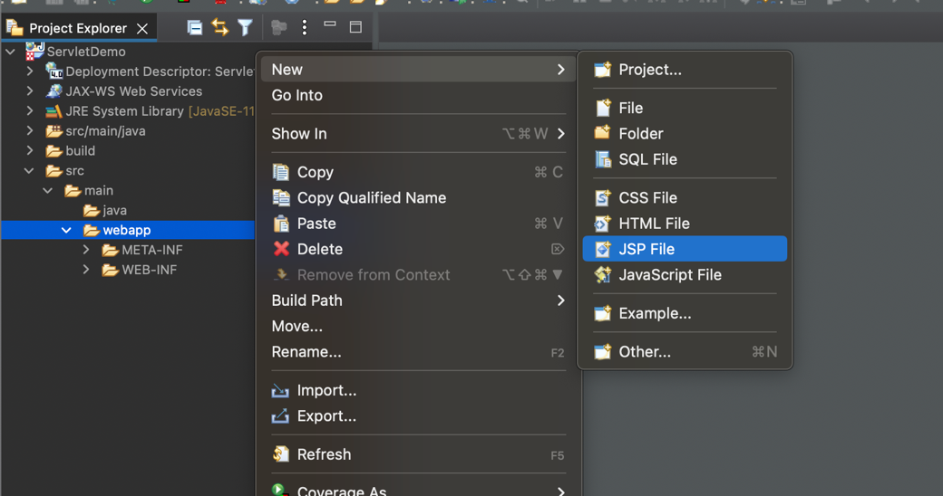
3. Add <h1>hello</h1>  
     
   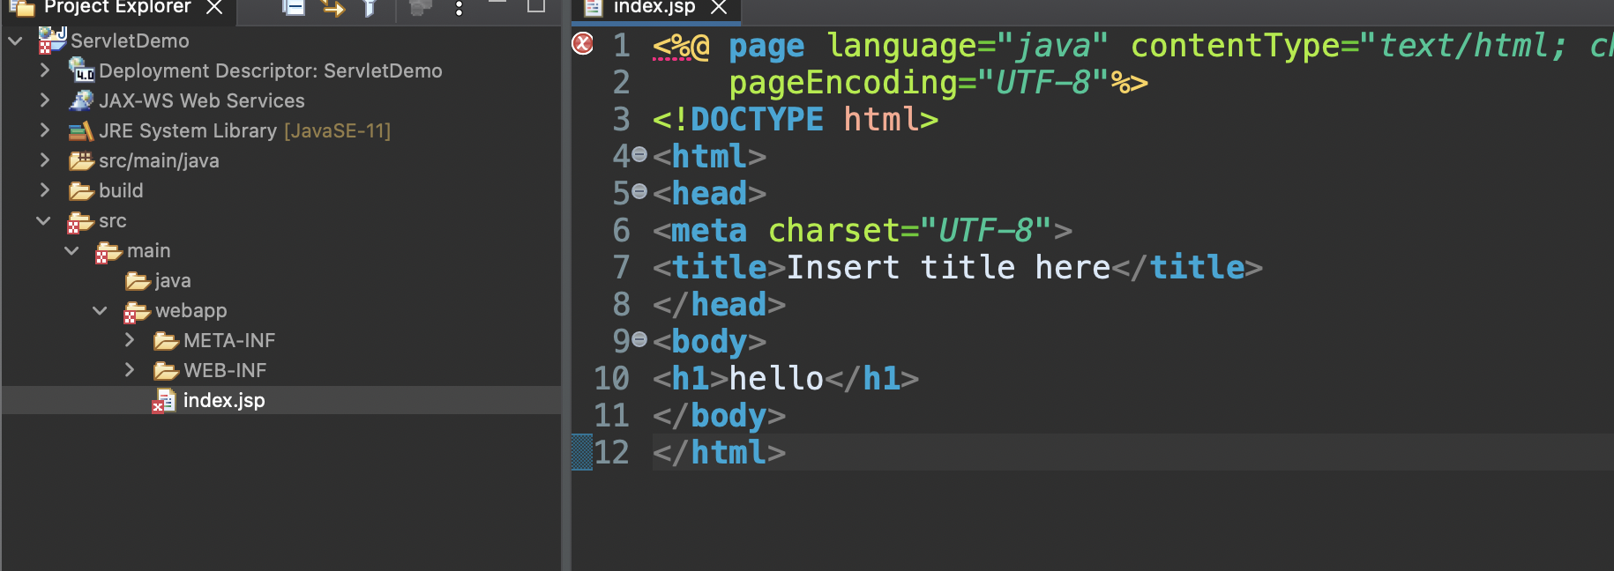
4. Then rt click Project -> Run As => Run On Server => Select Tomcat and finish.  
     
   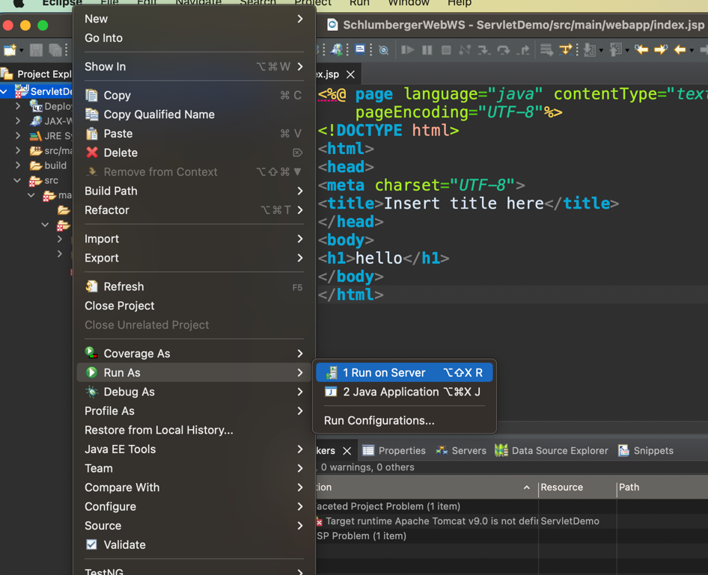  
     
   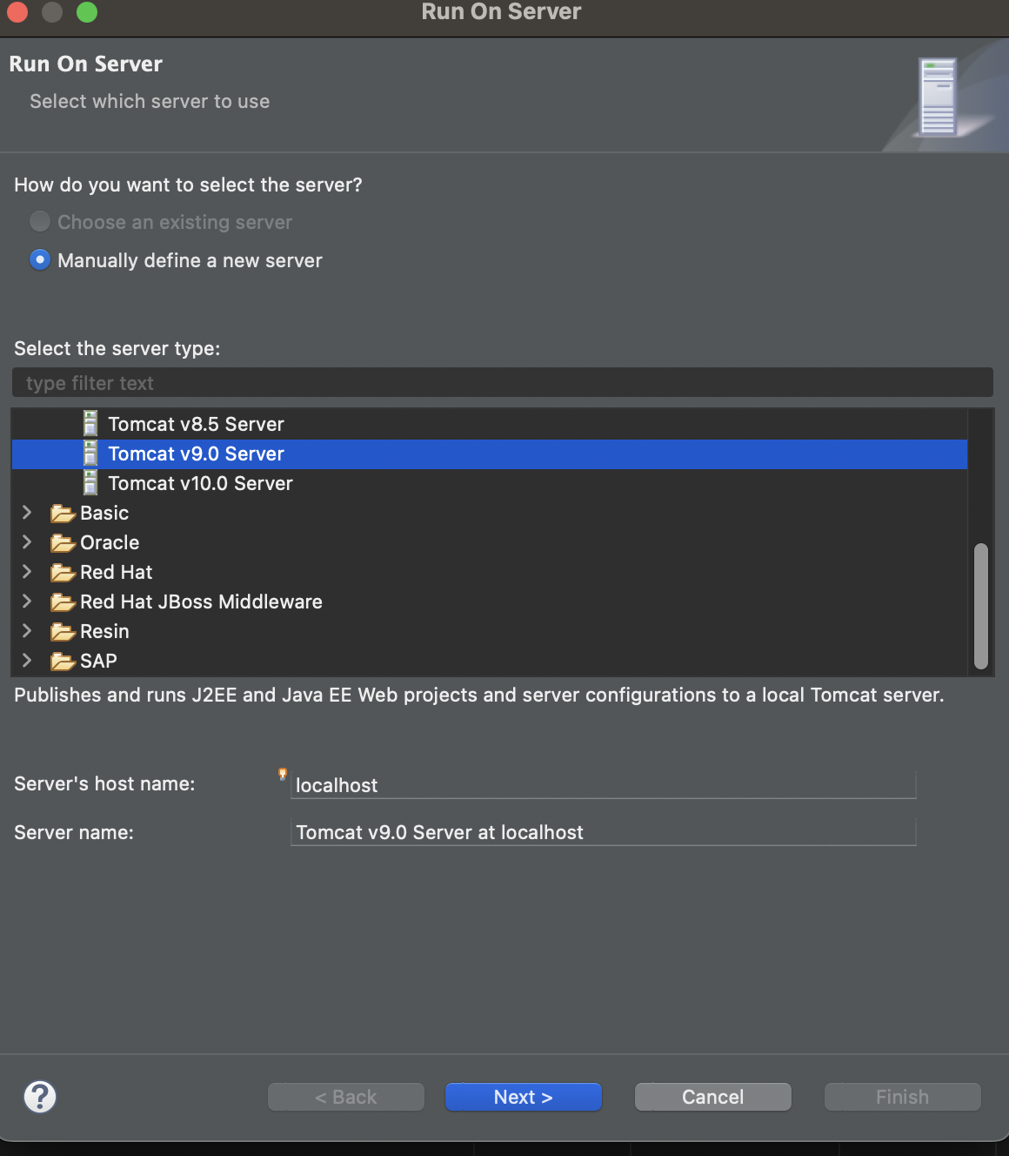
5. Should open the browser automatically and hello displayed  
     
   